**Date: 28-10-2021**



**SOFTWARE DESIGN AND ARCHITECTURE**

**LAB NO. 05**

**Domain Model**

Q1 **Consider a school management system. Draw a domain model for this scenario and identify conceptual classes by using following conceptual class category list i.e taught in lecture**

|  |  |
| --- | --- |
| Category List | Examples |
| Business Transaction | Payment |
| Transaction line item | Payment line |
| Product or service | Stationery, uniform |
| Where is transaction recorded | Register, ledger |
| Roles of people or organization | Students, teachers, administrator etc |
| Noteworthy events, often with a place or time we need to remember | Achievements, curricular and co-curricular activities |
| Physical objects | Building, transport, offices, class rooms, furniture, books |
| Description of things | Salary description, fee description |
| Catalog | Salary catalog, free catalog |
| Container of things (physical or informational) | school |
| Things in container | Students, administration, teachers |
| Other collaborating system | Tax agencies, examination board |
| Record of finance, work, contract, legal matters | Fee collection register and ledgers and salary records |
| Financial instrument | Cash, cheques |

Diagram:

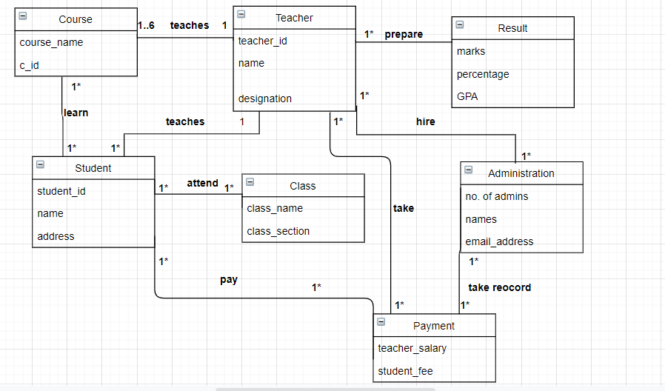

Q2 Consider the following use case and develop a Domain Modelusing a noun phrase identification technique to represent therelevant conceptual classes with attributes and the associationbetween them

Title: Deposit Money in ATM  
Primary Actor: Customer  
Main Scenario: The Customer approaches the Bank's ATM  
The customer inserts his/her card  
The ATM requests the customer's PIN  
The customer enters his/her PIN  
The ATM validates the customer's details  
The ATM displays a list of actions  
The customer selects deposit  
The ATM requests the money be inserted  
The customer inserts the money in the ATM  
The ATM adds up the money inserted and asks customer to confirm total  
The customer confirms the total  
The ATM updates the balance of the customer's selected account  
The ATM returns the customer's card.

**Nouns:**

Money, customer, bank, ATM, atm card, balance, account.

**Diagram:**

